WEEK 6

Mandatory Hands-On

**REACT**

**Create a React app named trainersapp**

1. **Explain the need and benefits of React Router**

React is a single-page application (SPA) framework, and by default, doesn't support page navigation. React Router enables dynamic routing, allowing users to navigate without reloading the page. It makes user experience seamless by preserving the application state between views. Routing improves code organization and separation of concerns by mapping paths to components. It allows deep linking, browser history support, and nested route handling.

1. **Identify the Components in React Router**

<BrowserRouter>**:** Wraps the app and manages the browser history.

<Routes>**:** Groups multiple <Route> components, enabling routing logic.

<Route>**:** Defines the path and the component to render when matched.

<Link>**:** Used for navigation without reloading the page (replaces <a>).

<Navigate> and <Outlet> help with redirection and nested routes respectively.

1. **List of the types of Router Components**

**BrowserRouter**: Uses HTML5 history API for clean URLs and is commonly used.

**HashRouter**: Uses the hash portion (#) of the URL, useful in static hosting.

**MemoryRouter**: Stores the URL history in memory (useful for tests or non-browser environments).

**StaticRouter**: Used mainly in server-side rendering (e.g., Next.js or SSR apps).

Each type serves a different use case depending on the environment and hosting.

1. **Parameter passing via url.**

URL parameters allow passing dynamic values through routes (e.g., /user/:id).

In the route component, you define a path like <Route path="/user/:id" element={<User />} />. You can access parameters using useParams() hook in the User component. Example: /user/101 will pass id=101 to the component. This technique enables dynamic rendering based on user interaction or data.

* Created trainersapp using *npx create-react-app trainersapp* in the directory Week6\ React\ trainersapp.
* Navigated to the React app and created trainer.js, TrainerDetails.js, TrainerList.js and TrainerMocks.js in src.

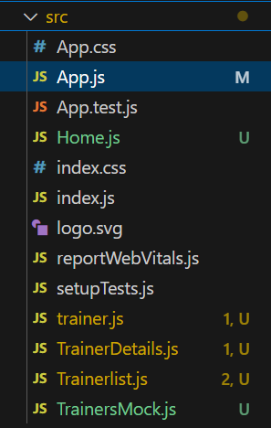

* Installed React router for the DOM using the command *npm install react-router-dom@6.*

**Trainer.js:**

class Trainer {

  constructor(trainerId, name, email, phone, technology, skills) {

    this.trainerId = trainerId;

    this.name = name;

    this.email = email;

    this.phone = phone;

    this.technology = technology;

    this.skills = skills;

  }

}

export default Trainer;

**TrainerDetails.js:**

import React from 'react';

import { useParams } from 'react-router-dom';

import trainersMock from './TrainersMock';

const TrainerDetail = () => {

  const { id } = useParams();

  const trainer = trainersMock.find(t => t.id === id || t.email === id);

  if (!trainer) {

    return <div>Trainer not found</div>;

  }

  return (

    <div>

      <h1>Trainers Details</h1>

      <h2>{trainer.name} ({trainer.specialization})</h2>

      <p>{trainer.email}</p>

      <p>{trainer.phone}</p>

      <ul>

        {trainer.skills.map((skill, index) => (

          <li key={index}>{skill}</li>

        ))}

      </ul>

    </div>

  );

};

export default TrainerDetail;

**TrainerList.js:**

import React from 'react';

import { Link } from 'react-router-dom';

const TrainersList = ({ trainers }) => {

  return (

    <div>

      <h2>Trainers List</h2>

      <ul>

        {trainers.map((trainer) => (

          <li key={trainer.id || trainer.email}>

            <Link to={`/trainers/${trainer.id || trainer.email}`}>{trainer.name}</Link>

          </li>

        ))}

      </ul>

    </div>

  );

};

export default TrainersList;

**TrainerMocks.js:**

import Trainer from "./trainer";

const trainersMock = [

  new Trainer('t-syed8',

    'Syed Khaleelullah',

    'khaleelullah@cognizant.com',

    '97676516962',

    '.NET',

    ['C#','SQL Server','React','.NET Core']),

  new Trainer('t-jojo',

    'Jojo Jose',

    'jojo@cognizant.com',

    '9897199231',

    'Java',

    ['Java','JSP','Angular','Spring']),

  new Trainer('t-elisa',

    'Elisa Jones',

    'elisa@cognizant.com',

    '9871212235',

    'Python',

    ['Python','Django','Angular'])

]

export default trainersMock;

**Sample Output:**

